## ****What Is Amazon Web Services?****

Amazon Web Services or AWS as an abbreviation is a popular Cloud Service Provider that enables on-demand services like compute, storage, networking, security, databases, etc which can be accessed through the internet across the globe and the user is not required to manage or monitor these resources.

Amazon Web Services is a global leader in terms of Public Cloud market share and provides cloud solutions in 245 different countries across the globe.  It provides more than 200 Cloud Computing services, which touch domains like,

* Storage
* Computation
* Security
* Databases
* Networking
* Monitoring
* Migration
* Messaging
* Analytics
* DevOps
* IoT
* Big Data, etc

Amazon Web Services (AWS) is a versatile, secure and reliable cloud service provider and is the most sort after Cloud Computing and Hard skill in the market.  Companies have invested billions of dollars in this service provider and the number shows an upward trend in the near future. The major reason why see this the market reach of Amazon Web Services, the quality of services and support it provides and the benefits it offers.

Let us now go ahead and see the benefits or advantages of using Amazon Web Services.

## ****Benefits of Amazon Web Services****

Amazon Web Services(AWS) offers numerous benefits, let us explore a few of these ones by one:

**AWS Pricing**

Whether you are a small scale startup or a full-fledged enterprise, Amazon Web Services has you covered when it comes to pricing.  Firstly it offers ‘pay as you go model’, that means you pay for resources in volumes and duration you use them for. It charges you on a per-minute basis. Meaning if a resource is used for 30 minutes you be charged only for those 30 minutes and not more. It also offers a calculator that lets you track your expenses.

**Zero Commitment**

Whether you need to host a website, or even a high traffic hosting content delivery network. Amazon Web Services keeps you covered. You spawn a virtual machine, a database service or a data warehouse. This happens with you not requiring to be in an upfront commitment. This is because Amazon Web Services charges you on per minute and for some resources per hour basis.  This means you are not tied with any yearly, quarterly or even monthly commitments.

**Scalability and Procurement**

If your applications lie on-premise, procuring your servers may take a lot of time. It can be a few hours to even 1- weeks. This holds true for your software licenses. Amazon Web Services paints a very different picture when it comes to procurement. You can launch new virtual machines or instances in a matter of minutes and save a lot of time and effort.

When it comes to scalability AWS ensures you can scale up and down instantly to adjust to spikes your infrastructure may face. This is something that can be difficult to achieve on your on-premise infrastructure.

**Security**

Amazon Web Services takes Cloud Security to the next level. It ensures your infrastructure is secure physically and also over the network, that consumers use to access it.

* It supports shared security model. This means the consumer can control security at the consumer end and AWS at data centre end.
* Physical security of data centre can be ensured by the fact that there is around the cloud physical security across all the data centres that Amazon Web Services owns
* Its Global infrastructure ensures your data is well distributed and accessible to you across the globe and is highly resilient, available and safe from disasters
* AWS provides firewalls to man your data at the entry points of the network and also ensures encryption of data that moves over the network, ensuring end to end security
* Amazon IAM is a service that lets you identify user who can access your resources and control who get to access what and when

**Flexible**

Not a lot needs to be said about the flexibility, when a platform offers, 200+ services in 245 countries. But to point out few key pointers, Amazon Web Services offers flexibility in terms of pricing, security, and even when it comes to automating the process scaling your devices.  It offers, IaaS, PaaS and even serverless computing. This means from configuring everything from a scratch to directly using a platform everything is flexible for a consumer. So much so that a user can just put his code in a serverless computing service and the service takes care of everything else.

**PaaS Offerings**

AWS offers an infrastructure that is scalable and also covers core domains, like compute storage, databases, networking. In the process, it takes care of configuring and managing platforms. Hence it provides good options when it comes to providing PaaS services to people. Meaning people do not have to worry about setting up infrastructures.

**Adaptable**

They say Amazon Web Services is everyone and that is very correct. Because it gives plenty of options when you want to set up your business on the cloud. If you are starting fresh with cloud or even if you have an infrastructure that needs to move to the cloud, AWS takes care of both situations. Amazon Web Services most types of migrations and license support for a smooth transition to AWS cloud

Your Scaling up and scaling down concerns are also nullified because AWS let us you handle data and applications in different volumes.

There are services that automate scaling and configuration processes. There are services like [AWS EC2](https://www.mygreatlearning.com/academy/learn-for-free/courses/what-is-aws-ec2?gl_blog_id=16380) that let you spawn instances in minutes and even create copies and backups of these instances ensuring you get adaptability that you were looking for.

**API**

API give us programmatic control over the resources we use. It comes to taking data backup, or even launching instances this all can be done API’s and in short, it gives us more power compared to AWS management console.

AWS Supports plenty of API’s and SDK’s that let you have control over these resources.

So this was about the benefits that AWS has to offer to us. Let us go ahead and take a look at some popular use cases.

## ****Use Cases of Amazon Web Services****

**Repp Health**

We all hate waiting in hospitals for a turn to come up. As a patient, we do not have patience and want to get done with our diagnosis at the earliest. And that is understandable behaviour. However, the number of people visiting a hospital and the staff having to set up all the equipment, are some reasons that cause these situations.

Amazon Web Services provides some relief here. With the help of AWS Repp has come with cloud-based tracking solutions. It helps keep track of patients and assets that reside in the vicinity and it makes use of IoT to do so. It also updates, electronic health records considering the data from sensors that capture the movements of patients in the room.

AWS offers Server-less IoT infrastructure to this achieve this and help save as much as it can, for speeding up the overall process at the hospital

**McDonald’s**

It is certain that most of us know what McDonald’s is? McDonald’s is a highly popular Burger and Fast chain across the globe. They have more than 37000 outlets across the globe and serve more than 60 million people every day. This gives you some idea as to the volume of customers they handle. It is no different for home delivery they provide.

However, having a home delivery platform for such a big vendor. Amazon Web Services ensured their home delivery platform was set up in just 4 months. It is a cloud-native microservices platform. It can scale up to 20000 orders per second and the latency is less than 100 seconds. This platform ensures high integration with delivery platforms and ROI even for minimally charged orders.

**WeWork**

Here is a case study where an application was moved from one service AWS to the other service on AWS. WeWork has built a tool for Project management called FieldLens. Initially, this was set up on Amazon Elastic Cloud Compute. This was a monolith project that functioned well for 2 and a half years. However, it needed expansion and improvement. This came in the form of Docker and AWS Elastic Container Service. On moving this project to containers the performance improved immensely.

Talking of numbers FieldLens, now hosts 80,000 users and 110,000 projects that use containers, and are deployed through AWS Codepipeline and secured using AWS Service. It offers high integration and scalability.

There are plenty of use cases and applications that Amazon Web Services offers. And there are many customers that have invested billions in this cloud platform and continue to do so on a monthly basis. That tell you how reliable this cloud platform is. To note a few popular customers, here are some names that you may want to know about:

## ****Popular Customers of Amazon Web Services****

1. McDonald’s
2. Netflix
3. Unilever
4. Samsung
5. MI
6. Airbnb
7. BMW
8. ESPN

# Microsoft Azure: Benefits, Use Cases, Applications | What is Microsoft Azure?

By [Great Learning Team](https://www.mygreatlearning.com/blog/author/greatlearning/) Updated on Jul 19, 2022 6349

Microsoft Azure is one of the leading cloud service providers and a strong competitor of Amazon Web Services. Microsoft Azure has plenty of features that make it one of the crowd’s favourites. In this article let us understand azure basic, [Introduction to Azure Essentials](https://www.mygreatlearning.com/academy/learn-for-free/courses/introduction-to-azure-essentials?gl_blog_id=16382), its benefits, use cases, [Microsoft azure application](https://www.mygreatlearning.com/academy/learn-for-free/courses/microsoft-azure-application?gl_blog_id=16382) and many more.

The following pointers will be touched upon in this article:

1. [What is Cloud Computing?](https://www.mygreatlearning.com/blog/microsoft-azure/#sh1)
2. [What is Microsoft Azure?](https://www.mygreatlearning.com/blog/microsoft-azure/#sh2)
3. [Benefits of Using Microsoft Azure](https://www.mygreatlearning.com/blog/microsoft-azure/#sh3)
4. [Use Cases of Microsoft Azure](https://www.mygreatlearning.com/blog/microsoft-azure/#sh4)

## ****What is Cloud Computing?****

 Let us see what the definition of Cloud Computing looks like?

‘Cloud Computing is nothing but a practice of providing Cloud Services (Storage, Computation, Databases, Security, etc) on rent and also through a network that can be accessed over the internet’

Now that we know what the general definition is, let us understand this concept with an example. To understand this definition, we need to go some 20 years back from 2020. In the early two thousand, in order to host an application, we needed to buy stack servers and have skilled professionals to set the infrastructure up. The process looked simple, but there were drawbacks,

* Servers were costly back then, and they still are
* It was difficult to find skilled professionals
* A lot of efforts went into planning

What this meant was the owner had to pay money in buying servers. Then invest more money in people who could set it up. The evening after a lot of planning, there was never certainty on how many resources were enough and how many were too much? As an owner, one would always worry about money resources, planning and scalability. Hence there was very less time one could devote to actually focus on business. Also, this meant setting up such business was becoming limited to ones who could afford it.

This is where Cloud Computing came to save the day. There were service providers in the market that started providing Compute, Storage, Networking, and other application hosting services on ‘pay as you go model’. This meant people could rent these services and pay for only those services they used and only for the time duration they used those for. Also, these services providers managed the configuration, scalability and management part.  In simple terms, this solved all the issues we listed above. This process we just discussed, evolved and started to be known as Cloud Computing.

So by now, you should have an understanding of Cloud Computing. Let us go ahead and understand the next topic

## ****What Is Microsoft Azure?****

Microsoft Azure is a Microsoft cloud service provider that provides cloud computing services like computation, storage, security and many other domains. Microsoft is one of the global leaders when it comes to Cloud solutions and global cloud infrastructure. Microsoft Azure provides services in 60+ global regions and serves in 140 counties. It provides services in the form of Infrastructure as a service, Platform as a Service and Software as a service. It even provides serverless computing meaning, you just put your code and all your backend activities as managed by Microsoft Azure.

It easily integrates with Microsoft Products making it very popular using Microsoft products. This platform is now 10 years old and it picked up to compete with the best of the best.

Let us now go ahead and see what benefits Microsoft Azure offers. You can also take up a [Microsoft azure certification free](https://www.mygreatlearning.com/academy/learn-for-free/courses/microsoft-azure-essentials?gl_blog_id=16382)course and learn more about the tool that has made an enormous stride in the cloud domain.

## ****Benefits of Microsoft Azure****



Microsoft Azure may be considered second to Amazon Web Services in few features, but it has quite a few that make it stand tall on its own. Let us take a look at them, one by one

**On-Demand Scalability**

When we talk of Application Hosting we can never be sure of how many resources are enough and how many are too much. This is the nature of businesses that rely on varying traffics. What is does is forces businesses to plan a lot and invest a lot of money doing it. Microsoft Azure helps you save all this effort.

Microsoft Azure ensures your applications and data is distributed well enough that means you never run short of Server space. It also means your applications do not run on a single server making them available even in dire situations. Since these resources are properly clustered out and they can scale at will and in no time, your applications function very differently then they would in an on-premise architecture.

**Cost Effective**

One of the major benefits with cloud service providers is the cut down of upfront costs. Since you can configure and scale at will, you are not required to invest heavily here. Microsoft Azure ensures small scale investment does not require upfront costs. Also when it comes to people who have signed up contracts, they get heavy discounts. It also offers to Pay as go, model, meaning you get cost-cutting in the right sense.

**Hybrid Environments**

They say cloud is not a one fit solution for all. It is true indeed because every business will have its own set of problems. And not all businesses will always be in a state where they can migrate to the cloud entirely. While other platforms suffer here, as people either have to migrate to those platforms or call it off totally, Microsoft Azure benefits with its Hybrid approach. Meaning, with Microsoft Azure you can build Hybrid infrastructures, where your resources can partially reside on the cloud and can partially operate from an on-premise infrastructure. Hence you are safe from costly workaround.

**Big data Applications**

Hadoop and Big data are the need of the hour. With data increasing exponentially we need applications that can help process this data. Microsoft Azure brings this capability of processing large volumes of data on top of its cloud platform. Azure HDinsight ensures you can use Apache Hadoop as a cloud solution. This is a power-packed service that lets you deal with large data volumes. That means your data crunching becomes easier.

It also readily integrates with data visualization tools and also lets you move your data to excel. This means your data visualization concerns are resolved quickly. With excel you can create visualizations and with PowerBI integrating with Microsoft Azure your data be converted into any visual that you require.

**Integration Capabilities**

Microsoft has been in the software industry for decades. It has wide reach in the software market and not many can compete with it when it comes to customer base and stack of products it offers. The advantage for Microsoft Azure here is that it readily integrates with most of these products. Be it, connecting to SaaS, PaaS, IaaS applications or even something like Visual Studio or Active Directory, Microsoft Azure has you covered. Hence you can now leverage ERPs and CRMs to enhance your business capacity to a greater level.

So should you be worrying if you do not use Microsoft Products. The answer is ‘NO’. You can even connect to or integrate many third party applications and services to widen your business reach.

**Storage and Security**

Storage is very critical to any application. It is no different for applications running on cloud. As already discussed, the volume of data we handle these days is huge. It also comes in different formats and from different sources. Your Storage resources have to adept enough to handle this data. Microsoft Azure has you covered here as well It lets you store data in form of files, objects, structured and unstructured data and a lot more. This happens reliable and securely.

Talking of security Microsoft Azure ensures high level of security for your applications. It ensures all the resources in Azure cloud are guarded with firewalls and data is moved over the network with encryption. You have access to authentication and access management meaning you data and application are secure to the core.

**Scheduling and Automation**

Everyone hates doing repetitive tasks. What if we could automate mundane tasks or recurring tasks be it fetching some data, setting up triggers or scaling your resources when needed? Microsoft Azure does that for you ensuring you can utilise your workforce for more productive outcomes and get rid of stagnancy or repetition of work.

**Data Backup and Recovery**

Data Backup ensures you have a copy of your data maintained in case if your primary copy of data or resources is lost. With Microsoft Azure, you have an option of backing up your data in different Azure regions or data centres. You can maintain as many as six copies of your data. This signifies that the chance of losing your data on Microsoft Azure is minimal. When it comes to reliability your data is available 99.9 percent.

So this was About the benefits of Microsoft Azure. Let us go ahead see do customers have to about Microsoft Azure and what are some of the popular use cases it has to offer to us.

## ****Use Cases of Microsoft Azure****

Microsoft has many popular customers out there, here are some use cases for you,

**University Of Toronto**

This is the largest Canadian university and leads the global front when it comes to research at an institutional fare. It made use of Microsoft Azure to avoid heavy hardware renewal costs. It migrated some of its activities to Microsoft Azure Cloud. With it, the university managed to transform IT processes, saving a lot of time

**AkzoNobel**

AkzoNobel is a popular Dutch Company that leads way in paint and coating business. It serves in more than 100 countries and always needs better connectivity across the globe. It harnessed the power of Microsoft Azure IoT services to improve its performance and connectivity at a global level.

**IHG (Intercontinental Hotel Group)**

This is one of the largest and leading hotel groups in the world. It owns around 5200 properties across the globe and serves more than a hundred countries. The fact that you own 5200 properties tells you the group holds its values of service very truly and also must have experimented a lot to stay up to date with market needs as well.  This fact is also supported by the fact that this group invests a lot of money in innovations to meet the experience quality the customers deserve.

The company has many of its tools that require Agile practices. It already was based on Azure Cloud platform. This is when they decided to use DevOps Services on Microsoft Azure. This not only helped them bring their software and data handling process on track, but also helped them fortify their security and processing principles. The fact that Microsoft Azure Supports Hybrid cloud meant big group like IHG did not have to move to Azure cloud altogether.

Ever since it has moved to Azure StorSimple, which is a hybrid storage service for enterprises. The group has achieved great results when it comes to storing data. It has helped them save more 70 percent in terms of cost. This is something that was initiated four years ago.  It needed very little support in setting up and does require too much intervention when it comes to administrative attention.

Before they moved to the above-mentioned service, IHG group had to deal with multiple data and file services to gather and store data. Azure StorSimple ensured this data was consolidated and easy to manage overall.  Data Backup issue was also resolved as Azure ensured that easy way to get a snapshot of data. That means data could be backed up easily and quickly.

So this was about different customers and how they used Microsoft Azure to solve their business problems. With this, we have come to the end of this article on Microsoft Azure: Benefits and Use Cases. We hope you liked this article and it has spiked your interest in learning or using Microsoft Azure.  We hope you perceive your Cloud Journey further, Happy Learning!

In case you have any questions, feel free to put those in the comment section and someone from our team will to your queries at the earliest. You can click on the below banner to get a free course on Microsoft Azure.

# Google App Engine

**Google App Engine** is an industry-leading Platform as a Service (PaaS) from the company that pioneered much of the microservices technology we rely on today.

In this blog, we are going to cover Google App Engine, its features, advantages, and use-cases.

## ****Google App Engine****

Google App Engine is a fully managed serverless platform for developing and hosting web applications at a scale. Users can choose from several popular languages, libraries, and frameworks to develop their applications and then  App Engine takes care of provisioning servers and scaling app instances based on demand. It is a PaaS for building scalable applications.



It is one of the Compute services offered by [Google Cloud Platform](https://k21academy.com/google-cloud/introduction-to-google-cloud-platform/).

## ****Google App Engine Environments****

Google Cloud provides 2 environments to use App Engine, one is a standard environment with constrained environments and support for languages such as Python, Go, node.js. The other one is the Flexible Environment where developers have more freedom such as running custom runtimes using docker, longer request & response timeout, and ability to install custom dependencies/software, and SSH into the virtual machine.

#### Flexible vs Standard Environment

#### 1.) Standard Environment

It is based on the container which runs on the Google infrastructure. It provides users with the facility to easily build and deploy an application that runs under heavy load and a large amount of data. It supports the following languages: Python, JAVA, Node.js, Ruby, PHP, and Go.

**Features of Standard Environment:**

* Persistent storage with queries, sorting, and transactions.
* Automatic scaling and load balancing.
* Asynchronous task queues for performing work outside the scope of a request.
* Scheduled tasks for triggering events at regular intervals or specific time intervals.
* Integration with other [Google cloud services](https://k21academy.com/google-cloud/google-cloud-services-tools-for-beginners/) and APIs.

#### **2.) Flexible Environment**

App Engine Flexible Environment allows users to concentrate on writing code. Based on [Google Compute Engine](https://k21academy.com/google-cloud/google-compute-engine/), it automatically scales the app up and down and along with it also balances the load. It allows users to customize their runtime and the operating system of their virtual machines using Dockerfiles.

**Features of Flexible Environment:**

* Infrastructure Customization: App Engine flexible environment instances are Compute Engine virtual machines, which implies that users can take advantage of custom libraries, use SSH for debugging, and deploy their own Docker containers.
* It is an open-source community.
* Native feature support: Features such as microservices, authorization, SQL and NoSQL databases, traffic splitting, logging, etc are natively supported.
* Performance: Users can take advantage of a wide array of CPU and memory configurations.

## ****Google App Engine Use-Cases****

**1.) Scalable Mobile Backends:**App Engine automatically scales the hosting environment for users who are building their first mobile application or looking to reach out to existing users via a mobile experience. It offers seamless integration with Firebase which provides an easy-to-use frontend mobile platform along with a scalable and reliable back end.

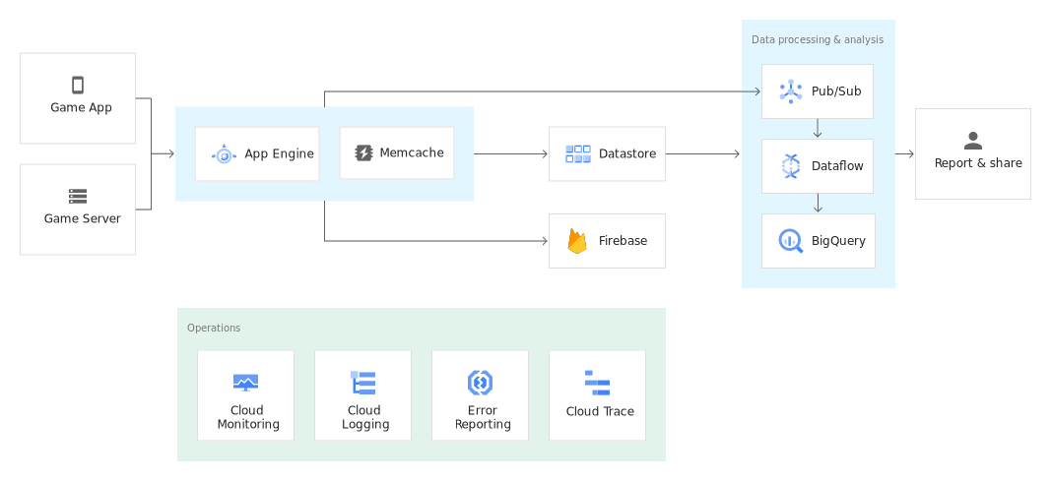

**2.) Modern Web-Applications:**Quickly reach customers and end-users by deploying web apps on App Engine. With zero-config deployments and zero server management, It allows users to focus on just writing code. In addition to this, it automatically scales to support sudden traffic spikes without provisioning, patching, or monitoring.

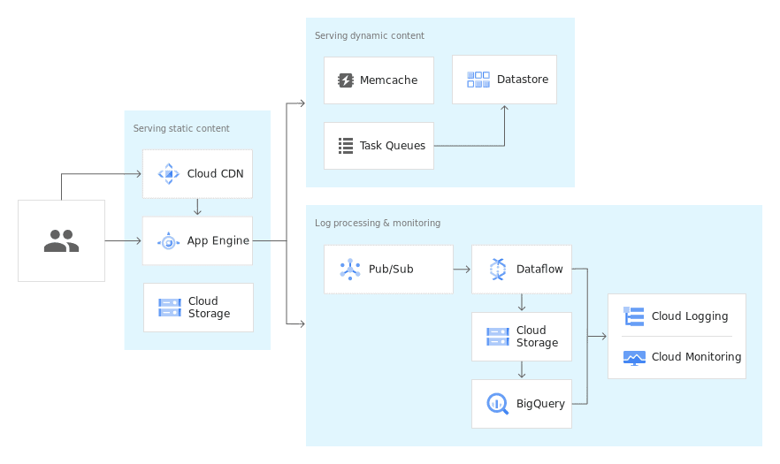

## ****Benefits of Google App Engine****

The main benefits of Google App Engine are:

* **Open and familiar languages and tools:** Users can build and deploy apps quickly using popular languages or bring their own language runtimes and frameworks, they can also manage resources from the command line, debug source code, and run API back ends easily.
* **Just add code:**App Engine protects from security threats using firewall capabilities, IAM rules, and managed SSL/ TLS certificates so that it helps users to write code without any underlying infrastructure.
* **Pay only for what you use:** It naturally scales relying upon the application traffic and expends resources just when the code is running.

## ****Features of App Engine****

Some of the prominent features of Google App Engine include:

* **Popular language:** Users can build the application using language runtimes such as Java, Python, C#, Ruby, PHP or build their own runtimes.
* **Open and flexible:** Custom runtimes allow users to bring any library and framework to App Engine by supplying a Docker container.
* **Fully managed:** It allows users to add your web application code to the platform while it manages the infrastructure. The engine ensures that web apps are secure and running and enables the firewall to save them from malware and threats.
* **Powerful application diagnostics:** Google App engine uses cloud monitoring and cloud logging to monitor the health and performance of the app and to diagnose and fix bugs quickly it uses cloud debugger and error reporting.
* **Application versioning:** It easily hosts different versions of the app, and create development, test, staging, and production environments.
* **Application security:** Google App Engine helps safeguard the application by defining access rules with an App Engine firewall and leverage managed SSL/TLS certificates by default on the custom domain without incurring any additional cost.